DATA 311 – Lecture 27 – Occam’s Razor, Overfitting, Data Splits, Cross-Validation

- Draw a function (not necessarily a straight line!) y = f(x) that “fits” the given data points for each of the plots below.

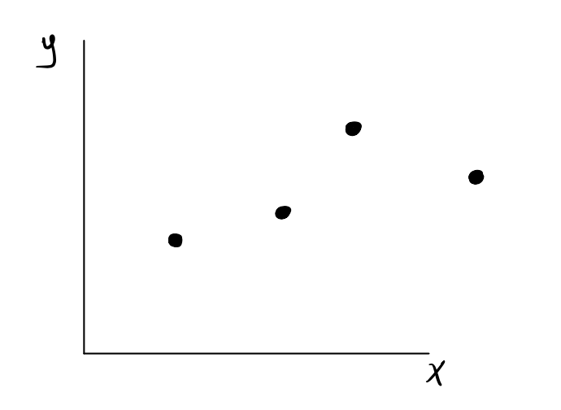
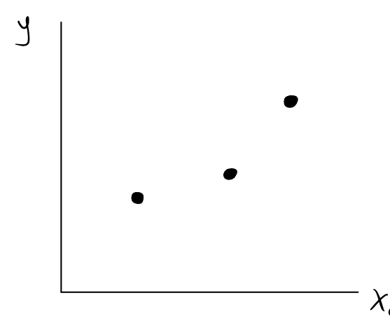

- Draw an function y = f(x) on the plot below (again, not necessarily a line) that overfits the training data depicted below.
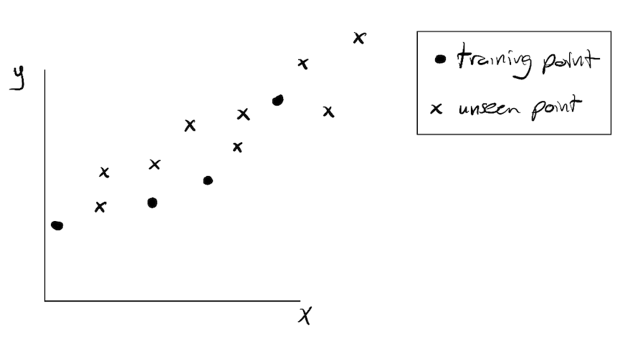
- Using a dashed line in the plot above, draw a function y = f(x) that underfits the training data.

- Consider the “your model” (dotted) lines in the plots below. One of them is high-variance model, and the other is high-bias model. Which is which?
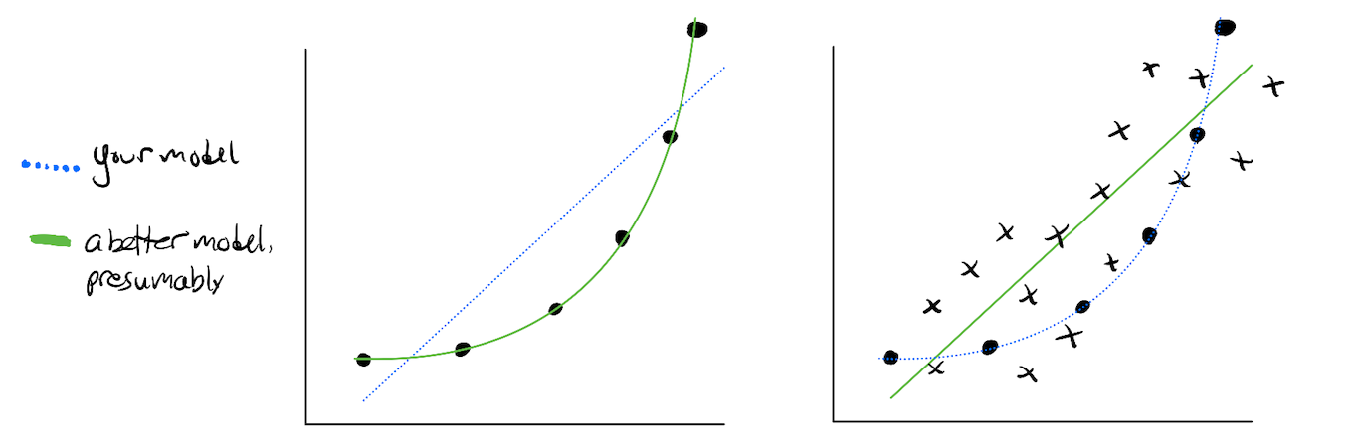

- Suppose you split your data into training and validation sets, train a model, and evaluate its accuracy on both the training set and on the validation set. How would you describe each of the four possible scenarios? Focus on the left column first.

 |  | Validation Accuracy
 |  | Bad | Good
Training Accuracy | Bad
 | Good

